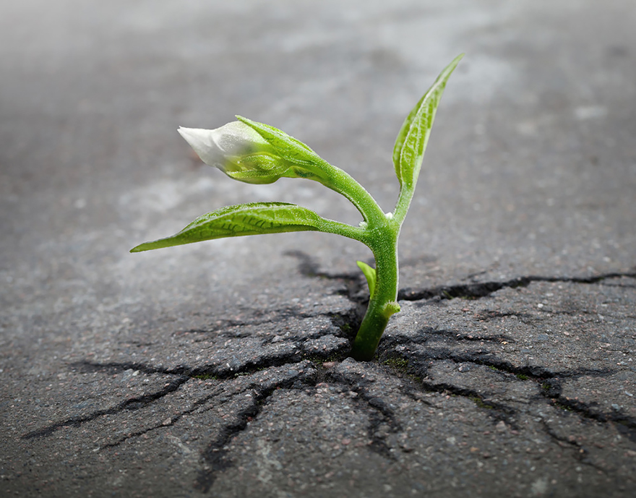  - Invitation to a webinar  Climate Justice Education:  The politics of food – responsibilities for adult educators  21 September 2022, 90 minutes  4pm (AEST), 10am (CET/CAT), 11:30am (IST)  This webinar continues to explore climate justice education (CJE). It focuses on the socio-natural-politics of food and the role of adult education.  Food binds us to each other and Nature which generously yields the nutrition we require. How could a transformation of food systems ensure the health and wellbeing of all? And how could it heal our relationship with nature? How can adult education support sovereign systems built on principles of agroecology and local wisdoms and create conditions where ‘enough is as good as a feast’?    For further information contact  astridvonkotze@gmail.com
  PIMA co-hosts the Climate Justice and Adult Learning and Education (ALE) Webinar Series with Canadian Association for Studies in Adult Education (CASAE), Adult Learning Australia (ALA), MOJA Adult Education Africa and Standing Conference on University Teaching and Research in Education of Adults (SCUTREA).
  ____
  The webinar is free and will be recorded. We look forward to you joining us! Please Register beforehand on the link below.
  In preparation please watch the short clip on food sovereignty https://www.youtube.com/watch?v=WuzoT_6CEEY https://www.youtube.com/watch?v=WuzoT_6CEEY
  sovereignty https://www.youtube.com/watch?v=WuzoT_6CEEY (7 1/2 mins)
  
  REGISTER HERE:
  https://us02web.zoom.us/meeting/register/tZ0pfuqspjgrE9WGP5aTI5o0rZo4rx8BaGwR

